HOMICIDE

The Lyon County Sheriff's Office is seeking your help

in the investigation of the homicide of Roger Leon Kelly

Case Number: 00-0092

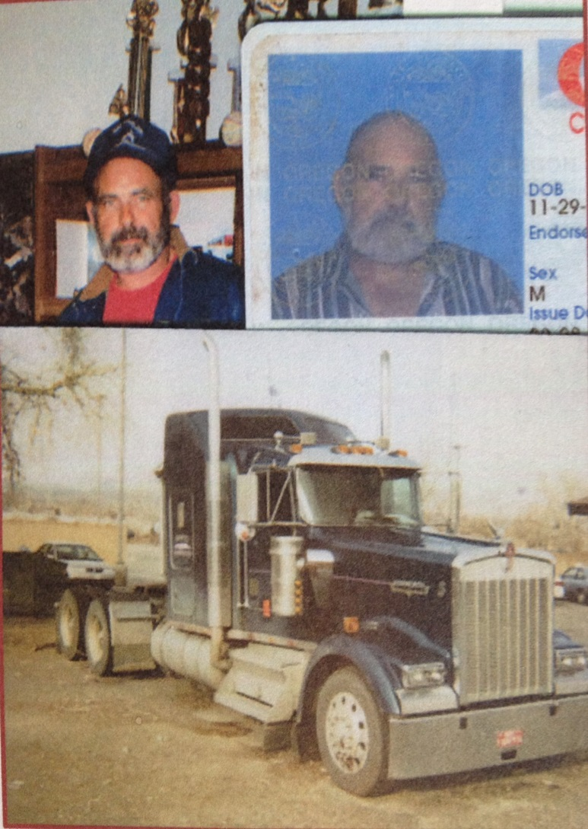
Current case status: Unsolved

Murder Date: January 09, 2000

Picture of person

Murder Location: Fernley, Nevada

Best Western Hotel

Roger Leon Kelly

Date of birth: November 29, 1949

Sex: Male

Height: 5 foot 6 inches

Weight: 160 pounds

Eyes: Blue

Hair: Grey

Race: Caucasian

On January 09, 2000, truck driver, Roger L. Kelly, was gunned down beside his truck at the Best Western Hotel in Fernley, Nevada. To this day Roger Kelly’s homicide remains unsolved.

The Detective Division of the Lyon County Sheriff's Office, as well as Roger Kelly’s family and friends, are asking for your help in solving this homicide case.

If you have any information about Kelly’s murder, you are urged to contact the Lyon County Sheriff’s Office Detective Division.

Call

LCSO Detective Division: (775) 577-5206

LCSO Dispatch Center: (775) 577-5023

Secret Witness Tip Line: (775) 322-4900

